# Meeting – 10/12/15

For the home screen we have decided to remove the burger menu and remodel the main screen. The burger menu was too thin to contain the hierarchy of the menu items we need. Instead, we are using a sort of implementation like the picture below where the main screen is the new menu page

We haven’t decided how to take into account smaller screens i.e. whether to display it as 3x3 with only 8 menu categories or not.

We thought that circles are a good idea, but a lot of whitespace results from this, as 2x4 doesn’t look very nice and 3x3 doesn’t; take up much room.

There was also the idea of having Windows-esque tiles that would make better use of the space.

Also, we were thinking of having the most used apps at the top, so if settings was the most accessed feature (I don’t know why it would be, but whatever) that would be at the top so it’s easier to access.

TODO – design a low fidelity prototype of what you think the main screen should look like and how it should display the menu categories from below.

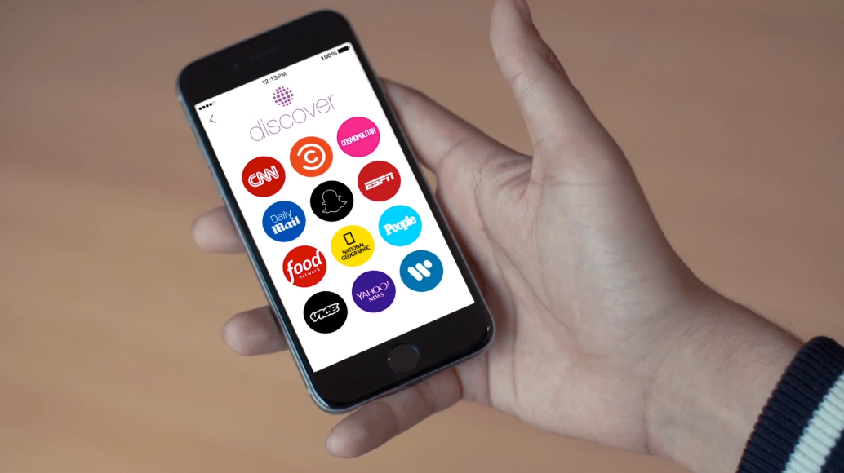

## New menu category:

* Articles (looks like the card view from google now)
* Books
* Baby Profile
  + Where you can check baby data like charts, age etc.
  + Gives you the ability to change between babies
* Forums
* My Account
* Favourites
* Settings
  + Has the tutorial
  + Whatever else we’ll decide to add later
* Contact Us
  + Has the What we do section

NOTE: This menu is hardcoded in and will not change, however, the articles menu will

NOTE: each category, when selected, will slide in from the right giving the illusion that the main menu is like our old burger menu but isn’t actually a burger menu

## Search:

We decided there would be a search option on the Main, Articles, Books and Forum pages. On the main pages we will have an entire app search function that gives a maximum of two results from Articles, Books and Forums (like how Windows 10 search works)

On the other pages, search would only look through that specific section

PRIORITIES:

Coding wise

* Get the articles section done
* Get the Baby profile page done
* Decide on the layout of the main menu so we can get that done too

AFTER THAT:

* Books menu will stay as was in the first medium fidelity (can be found on slack in the Documentation section)
* Contact Us is easy enough to fill in
* Settings, we’ll decide what goes in there later
* Tutorial, again, once we’ve finished the app we’ll have a look at that
* Forum, since there’s a possibility we won’t use this we’ll have to check